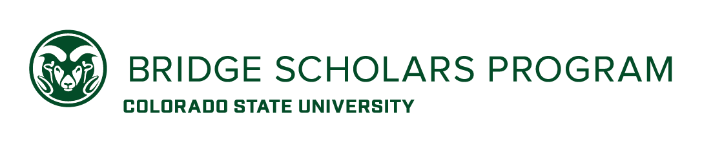
JOB DESCRIPTION / POSITION ANNOUNCEMENT

Bridge Scholars: Student Program Assistant
The Access Center

PROGRAM PURPOSE
Bridge Scholars are first-generation college students from limited socio-economic communities admitted to CSU for the 2022-2023 academic year. Bridge Scholars start their first year the summer prior to fall and enroll in six University credits.

The Student Program Assistant will provide support in recruiting and preparing Bridge Scholars for the 2022 summer program during the spring semester. This position can be a combination of in-person and remote work.

MINIMUM QUALIFICATIONS:
- Be a current CSU student enrolled in the 2021-2022 academic year
- Demonstrate understanding of first-generation student/community experiences
- Must have work study
- Minimum Cumulative GPA: 2.75

PREFERRED QUALIFICATIONS:
- Effective communication skills: Ability to speak to large and small groups and ability to create communications using different types of mediums.
- Group Facilitation Skills: Ability to develop engaging presentations and workshops for large and small groups.
- Fluent in Spanish
- Alumnus of the Colorado State University Bridge Scholars Program

RESPONSIBILITIES
- Assist in Recruitment Efforts and Promotion of the Bridge Program
  - Conduct Bridge information session via Zoom.
  - Outreach and follow-up with potential Bridge applicants via text, phone call, or email.
  - Attend events such as Choose CSU and high school college nights to promote the Bridge program.
- Assist Future Bridge Student with Transition into Summer Program
  - Follow-up with and assist students in completing their requirement (FAFSA, Registration, Etc)
  - Tracking progress of the 2022 cohort as they complete their process to enrolled in the summer.
  - Prepare materials and documents for student/family meetings that may be in-person or virtual and launch of the summer program.
  - Collaborate in planning special activities and events.

PAY & STARTING DATE:
This is a work-study position paid at $15.00/hr. for 10-15 hours per week. Start date is expected to be January 18th through the end of the 2022 spring semester.

APPLICATION PROCESS:
Applications will be considered until positions are filled, however, to ensure full consideration, submit your cover letter and resume via email to angel.ruiz@colostate.edu by December 6th by 5:00pm. Target start date is January 18th.

If you have questions about the position, please contact Angel Ruiz, Coordinator of Educational Bridging Experiences via email at angel.ruiz@colostate.edu or Lucia Delgado, Director of College Access at lucia.delgado@colostate.edu

Colorado State University does not discriminate on the basis of race, age, color, religion, national origin or ancestry, sex, gender, disability, veteran status, genetic information, sexual orientation, or gender identity or expression. Colorado State University is an equal opportunity/equal access/affirmative action employer fully committed to achieving a diverse workforce and complies with all Federal and Colorado State laws, regulations, and executive orders regarding non-discrimination and affirmative action. The Office of Equal Opportunity is located in 101 Student Services. Colorado State University is committed to providing a safe and productive learning and living community. To achieve that goal, we conduct background investigations for all final candidates being considered for employment. Background checks may include, but are not limited to, criminal history, national sex offender search and motor vehicle history.

